1.All lab programs(1-9)

2. (i) Import all the necessary libraries required for creating the neural network model given blow

(ii) Construct the model using **Sequential API**. Consider the corresponding activation functions as specified in the Layer Type, and Chose the number of units in each layer accordingly.

(iii) Compile the model with the following details and print the model as shown below

* 1. Optimizer = Adam
  2. Loss function = Choose appropriately from the layer types
  3. Metrics = Choose appropriately considering the binary class classification task

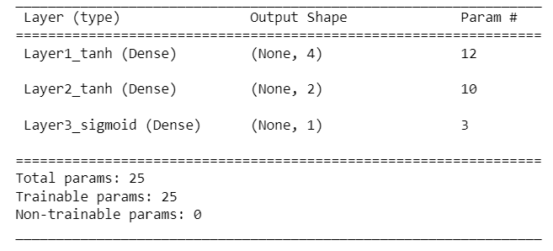

3. (i) Construct a vector consisting of first 24 integers using 'numpy'.

(ii) Convert that ‘numpy’ vector into a Tensor of rank 3.

(iii) Write your observations on how the elements of the vector got rearranged in the rank 3 tensor.

4. (i) Import all the necessary things to create the model as described in the summary below.

(ii) Construct the model using **Functional API**. Consider the corresponding activation functions as specified in the Layer Type, and assume that the input is of shape **28x28x1**. The kernel size of the convolutional layer should be **3x3**. Chose the number of filters, padding, and stride accordingly.

(iii)Compile the model with the following details and print the model summary as described below.

* 1. Optimizer = Adam
  2. Loss function = Choose appropriately from the layer types
  3. Metrics = Choose appropriately considering the multiclass classification task

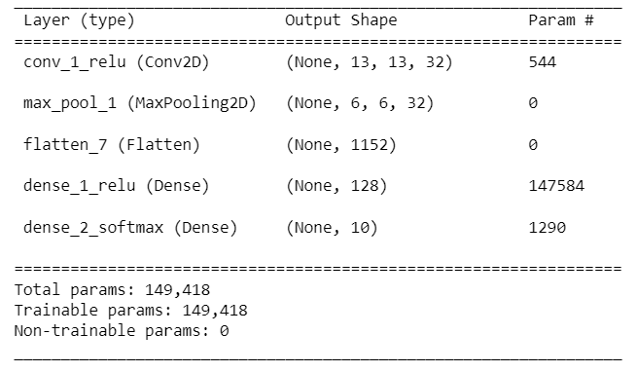

5. Write the Code for implementing the LSTM model for the sentiment Analysis on IMDB Movie Reviews dataset with ‘RMSProp’ Optimizer?.

6.Perform Image Classification using CNN

DATASET: https://www.kaggle.com/datasets/fanconic/skin-cancer-malignant-vs-benign

7. Design and implement a CNN model (with 4+ layers of convolutions) to classify multi category image datasets. Use the MNIST, Fashion MNIST, CIFAR-10 datasets. Set the No. of Epoch as 5, 10 and 20. Make the necessary changes whenever required. Record the accuracy corresponding to the number of epochs.

8. Implement the standard VGG-16 & 19 CNN architecture model to classify multi category image dataset and check the accuracy.

9.design a DL model and show the use of Dropout layer.

10.design a DL MODEL using Tranfer learning.

11. design a DL model and show the use of Early stoping.

12. design a DL model which uses Data Augmentation Techique.

13..design a model to predict next word..

14. (i) Get the version of TensorFlow running on your machine?

(ii) Get the type & number of physical devices available on your machine, print what are they, and test whether the GPU is available?